**ITS 26000 – Applied Database Tech**

**Lab 08 – (100 points)**

**Use SQL to complete the following exercises.**

### **KimTay Pet Supplies:**

* 1. In the attached script (Customer1.sql), a table named “Customer1” is created and several rows are inserted into this table. Compared with “Customer” table which is already inside KimTay database, “Customer1” has an additional column called “Refer_ID”, which stores the cust_ID of the customer who referred the current customer.

Please use “Customer1” table instead of original “Customer” table and write two ways to display the customers’ full name who referred at least two customers. (15 points)

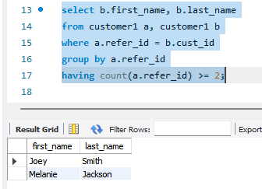

select b.first_name, b.last_name

from customer1 a, customer1 b

where a.refer_id = b.cust_id

group by a.refer_id

having count(a.refer_id) >= 2;

select first_name, last_name

from customer1

where cust_id in (select refer_id

from customer1

group by refer_id

having count(refer_id) >= 2);

* 1. List the invoice number and invoice date for each invoice that contains an invoice line for a Wild Bird Food (25 lb). (15 points)

select a.invoice_num, a.invoice_date

from invoices a

where a.invoice_num in (select invoice_num

from invoice_line a, item b

where a.item_id = b.item_id and b.description = "Wild Bird Food (25 lb)");

* 1. List the invoice number and invoice date for each invoice that was created for James Gonzalez but that does not contain an invoice line for Wild Bird Food (25 lb). (15 points)

select a.invoice_num, a.invoice_date

from invoices a

where a.cust_id = (select cust_id

from customer1

where first_name = "James" and last_name = "Gonzalez") and

a.invoice_num not in (select invoice_num

from invoice_line a, item b

where a.item_id = b.item_id and b.description = "Wild Bird Food (25 lb)");

* 1. List the item ID, description, unit price, and category for each item that has a unit price greater than the unit price of every item in category CAT. Use the ALL operator in your query. (10 points)

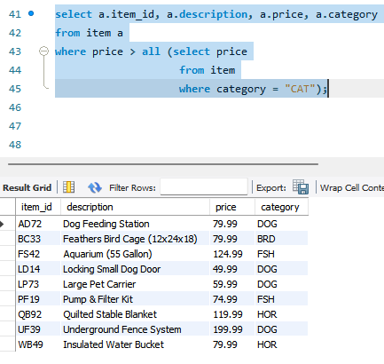

select a.item_id, a.description, a.price, a.category

from item a

where price > all (select price

from item

where category = "CAT");

1. **StayWell Student Accommodation:**
   1. Find the service ID and property ID for each service request whose estimated hours are greater than the number of estimated hours of at least one service request on which the category number is 5. Use the ANY operator in your query. (10 points)

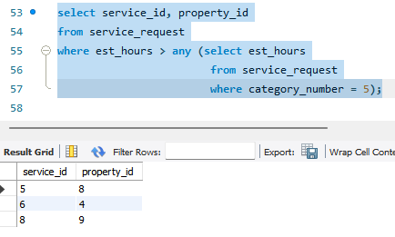

select service_id, property_id

from service_request

where est_hours > any (select est_hours

from service_request

where category_number = 5);

* 1. List the address, square footage, owner number, service ID, number of estimated hours, and number of spent hours for each service request on which the category number is 4. (15 points)

select b.address, b.sqr_ft, b.owner_num, a.service_id, a.est_hours, a.spent_hours

from service_request a, property b

where a.category_number = 4 and a.property_id = b.property_id;

* 1. Repeat above question (b), but this time make sure each property is included regardless of whether the property currently has any service requests. (10 points)

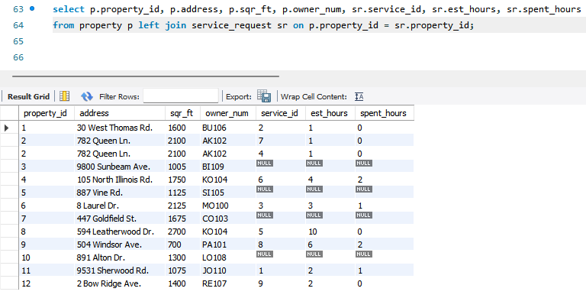

select p.property_id, p.address, p.sqr_ft, p.owner_num, sr.service_id, sr.est_hours, sr.spent_hours

from property p left join service_request sr on p.property_id = sr.property_id;

* 1. Repeat above question (c) using a different SQL command to obtain the same result. What is the difference between the two commands? (10 points) (Hint: use Right Join)

select p.property_id, p.address, p.sqr_ft, p.owner_num, sr.service_id, sr.est_hours, sr.spent_hours

from property p right join service_request sr on p.property_id = sr.property_id;

**Deliverables**: **Document Report with the SQL statement/Query and snapshot of query, its execution and results.** Either word or pdf file need to be uploaded into Brightspace in one submission